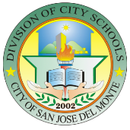
Republic of the Philippines
Department of Education - Region III
CITY SCHOOLS DIVISION OF SAN JOSE DEL MONTE
City of San Jose Del Monte
___Website: www.deped.csjdm.webs.com/e-mail:deped_csjdm@yahoo.com/telefax(044 )815 2815___

MONTHLY CLASS OBSERVATION REPORT

SCHOOL: _________________________________________ District: _________________________________________
Principal/School Head: ______________________________
Date | Name of Teacher | Grade & Subject | Observations/Findings | Recommendations | Technical Assistance Given

Prepared: _______________________________
Noted: ______________________________________ School Head/Principal
District Supervisor

