DEPARTMENT OF EDUCATION
Region III – Central Luzon
NAME OF SCHOOL
Address

SUMMARY OF SPEED TES
SCHOOL NAME
NAME OF BARANGAY
SERVICE PROVIDER
DATE
TIME | UPLOAD (Mbps) | DOWNLOAD (Mbps)
9:00 am – 10:00 am
1:00 pm – 2:00 pm
4:00 pm – 5:00 pm

- Speed Test result @ 9:00 am – 10:00 am
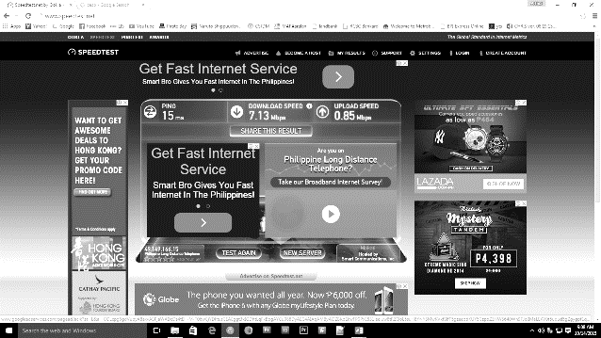

- Speed Test result @ 1:00 pm – 2:00 pm

- Speed Test result @ 4:00 pm – 5:00 pm

Prepared by:

Signature over-printed name (IT Coordinator)

Approved by:

Signature over-printed name (School Head)

