P R O G R A M M E
Part I - CARAVAN
- Newtown –Districts 1- 3 (Blue Balloons)
- BBH San Rafael ES – Districts 4-5 (White Balloons )
- SJDM West Central School – Districts 6-7 & SDO (White Balloons)
- Tungkong Mangga ES – District 8-10 (Red Balloons )
- Christian Ecclesiastical School – Private Schools (Yellow Balloons )
Part II – PRE – PROGRAM
Presentation of Videos
Laro ng Lahi ……………………………………………………….. CHITO REPOREN
Principal II
Roll Call ……………………………………………………………….. ESPERANZA A. DIAZ-CRUZ EPS - I
Part III –PROGRAM PROPER
National Anthem
Doxology ………………………… SPA Students, Sapang Palay National High School
CSJDM Hymn
Welcome Message……………………………………………… GERMELINA H. PASCUAL
Schools Division Superintendent

Intermission Number……………………………………… SPA Students, San Jose Del Monte National High School

Message of Support/ Commitment ……………………… ANGELU MARIE LEONOR
Grade 10 Student
ENGR. ROEL C. NOROŇA
President, Division GPTA Federation
ANN LIZA R. LEPASANA
Head Teacher, Paradise Farms National High School
ELIZA U. JARABE
Principal I, Minuyan National High School
ESMERALDA CABAHUG
Store Manager, Savemore
RIZALINO JOSE T. ROSALES
OIC-Regional Director
HON. REYNALDO S. SAN PEDRO
City Mayor
HON. ARTHUR B. ROBES
Congressman, City of San Jose Del Monte
HON. WILHELMINO SY-ALVARADO
Governor, Bulacan

Intermission Number ……………………………………… SPA Students, Muzon National High School
Tayo Para sa Edukasyon Campaign Video
K to 12 Presentation ………………………………………….. MARLON P. DACLIS
EPS – I
Open Forum………………………………………………………… ROLANDO T. SOTELO
Chief, Curriculum Implementation Division
Intermission Number…………………………………………… SPA Students, Sapang Palay National High School
Signing of K to 12 Commitment Wall…………………… All Delegates
Announcement of Winners
Closing Remarks………………………………………………… MARIA CARMEN P. CUENCO
OIC – Asst. Schools Division Superintendent

Don Uriel D. Buenaventura
Maria Eleonor B. Del Rosario
Masters of Ceremony

So help me God.
In every instance in which my position, skills and competencies are needed to promote K to 12, I commit to offer myself in the manner called for.

I will attend and support activities geared to protect the interests of the Filipino Youth who will benefit from the fundamental mission of the Program.

meaningfully contribute to building the nation through active and significant involvement in the
K to 12 Program.

As a stakeholder in the future of the Filipino people, I
(state your name), (state your position), pledge to passionately love my country and commit to the Department of Education's goal to

Pledge of Commitment

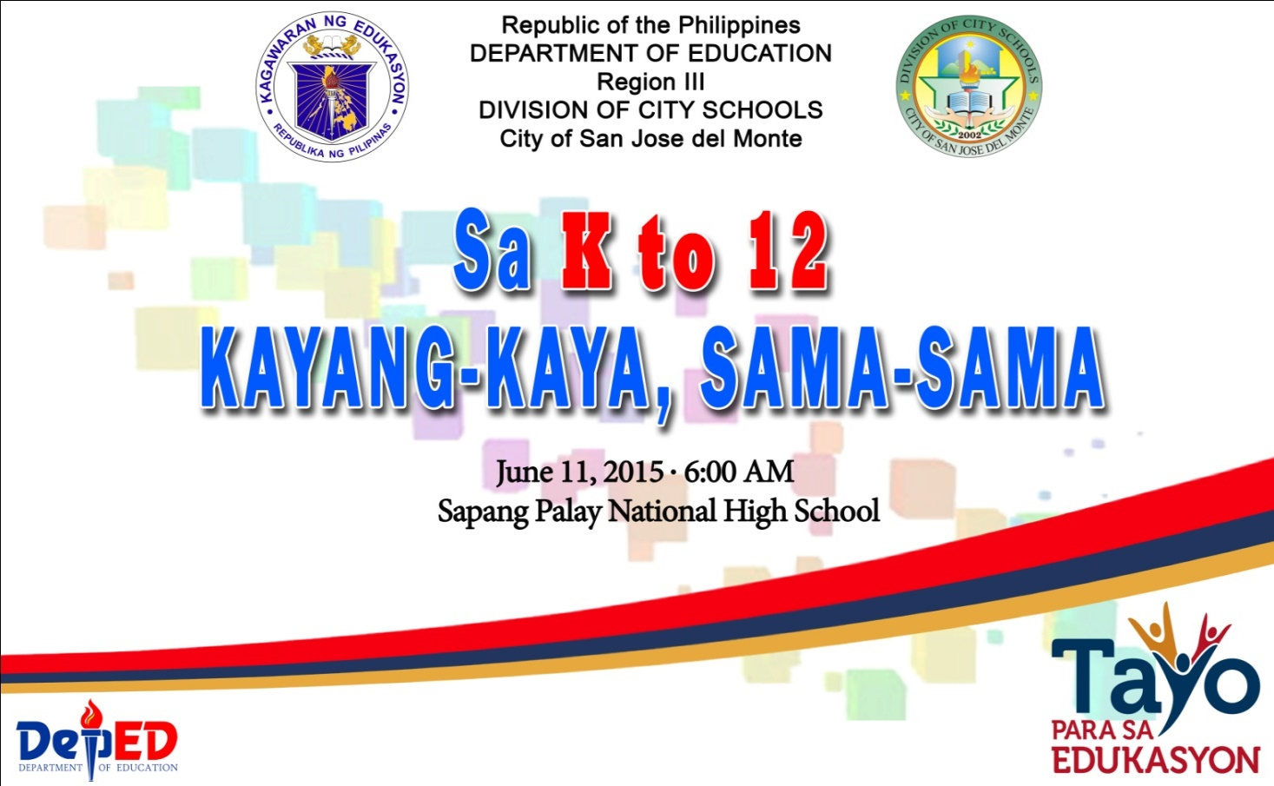

_________________________________________________
This serves as an invitation

